ZERO WASTE ( POLLUTER PAYS)

From the point of view of matter, the world is a closed system. For increasing demands on the world's limited resources and for a sustainable life, our aim is to spread the awareness of zero waste and to implement various practices.

AİMS

Recycling economy
Control of environment pollution
Prevention of waste generation, efficient use of resources
Reducing costs by avoiding waste
Reducing environmental risks
Creating environmental and sensitive consumer awareness
Recycling of waste
Increasing the prestige of environmental institutions
Lifelong learning
Enhancing cultural awareness and creativity
Intercultural communication
Enhancing the use of the technology-supported teaching environments and Web 2.0 tools.

EXPECTED RESULTS

To bring the linear economy concept to a cyclical structure to live without waste, to develop environmental and sensitive consumer awareness, to ensure efficient use of resources.

PROJECT PROMOTION VIDEO

We prepared project promotion video in three languages.

GOALS

We asked the students about the types of waste they would like to work with during the project using the Mentimeter web.2 tool.

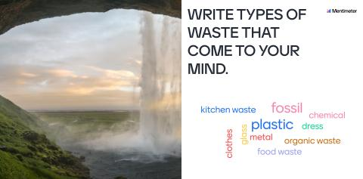

MIXED TEAMS OF PROJECT
We used KEAMK web.2 tool to build our teams.
TEAMPLASTIC | TEAMBATTERY | TEAMCLOTHES | TEAMPAPER | TEAMGLASS
MERCAN | FIRAT | YÜSRANUR | RIDVAN | MENESE
REBECA | ÖMERİSLAM | DENIS | YETER | ECRİN
GABRIEL | NERGİSŞAH | MİRAÇ | ARIADNA | MİZGİN
ÖMER | MİRAN | RAMAZAN | YAKUP | ALİŞER
RECEP | LUSTIN | İZEMAZRA | AYŞE | MUSTAFA

MATCHING ACTIVITY
Our students played the wordwall game after the project presentation.

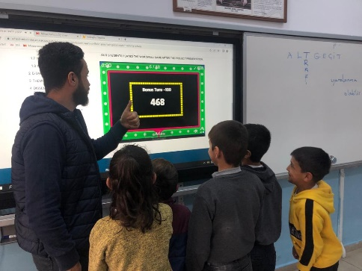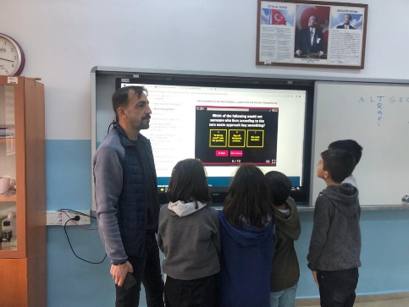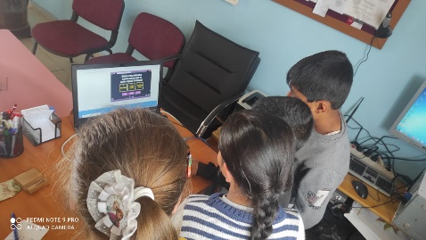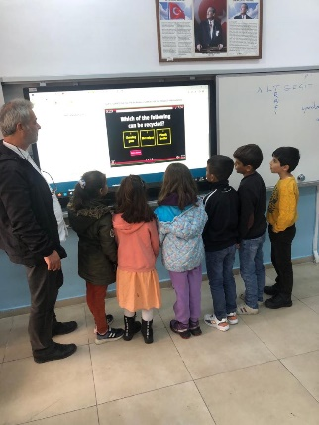
DECEMBER EVENT
This month we installed collection equipment for separate collection of waste. We made our parents and students aware of zero waste. We have prepared our zero waste board. We made the children watch videos and cartoons.

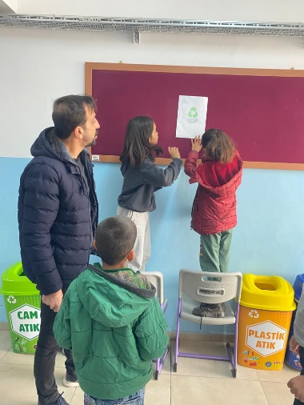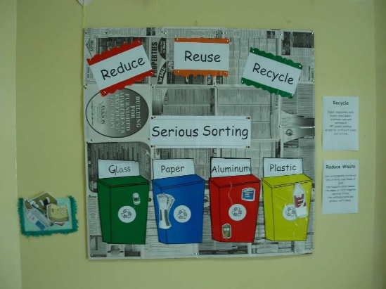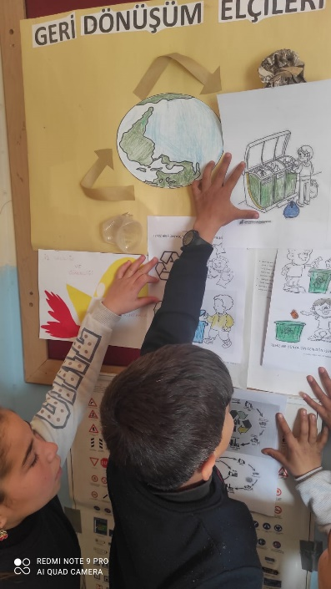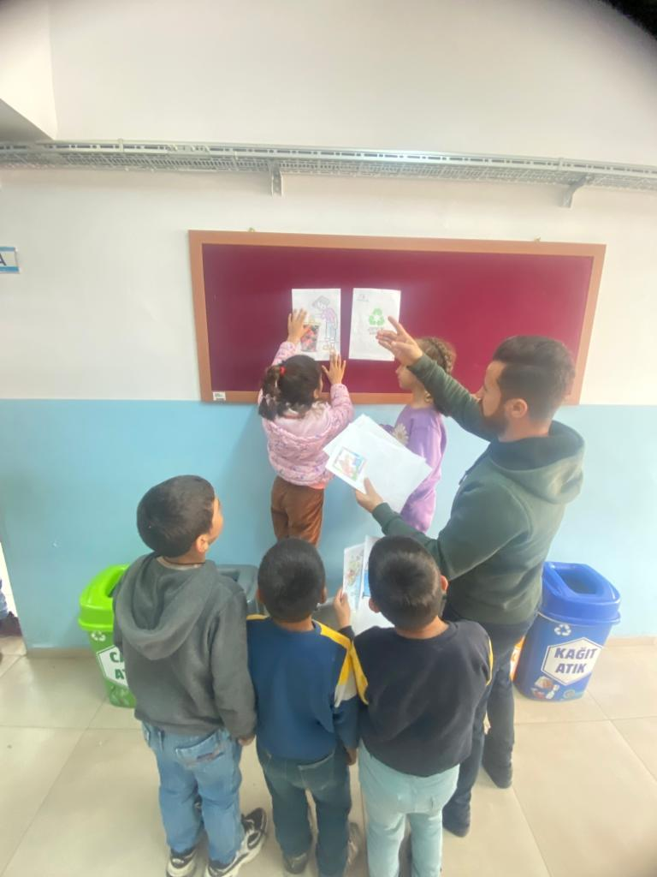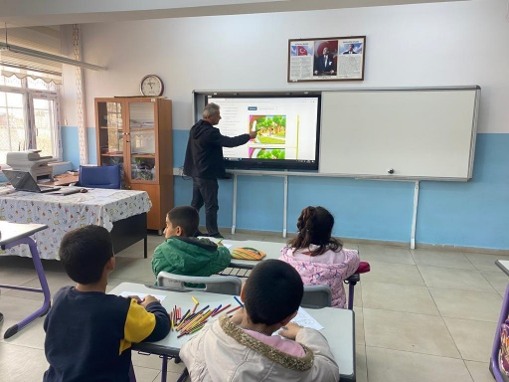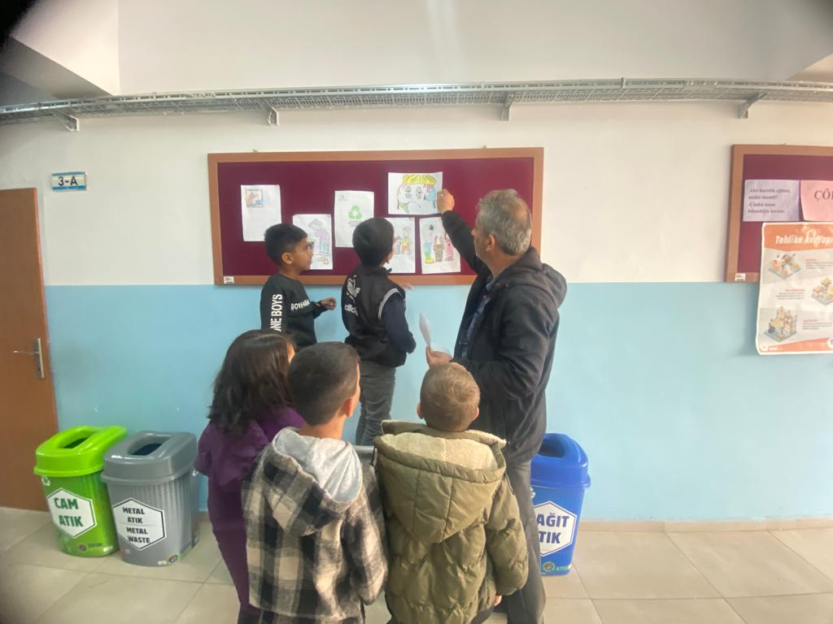

JANUARY EVENT
As part of the zero waste project, we collected paper and cardboard with our students and delivered them to the necessary institutions.

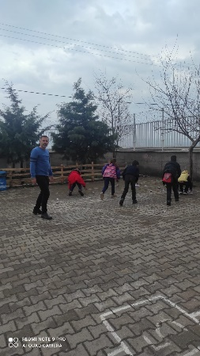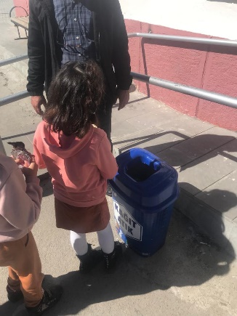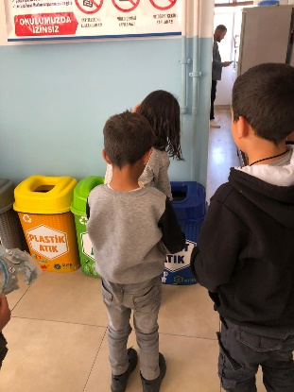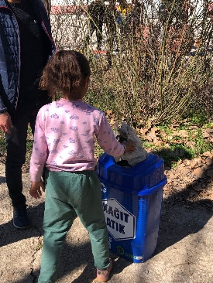

FEBRUARY EVENT
As part of the zero waste project, we collected plastic bottles and plastic materials around our school with our students.
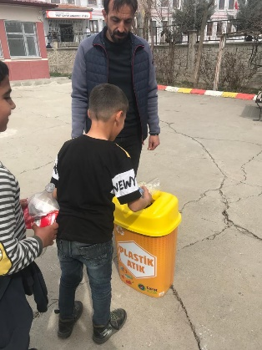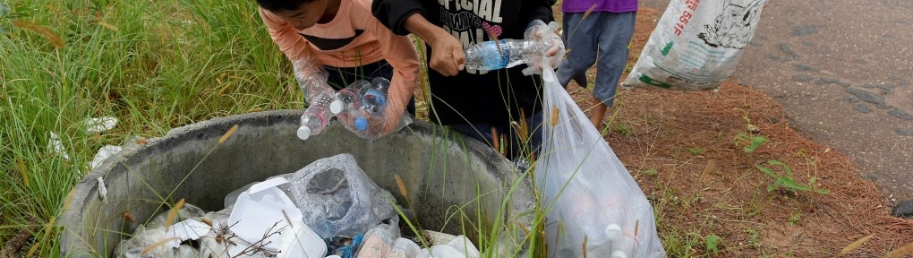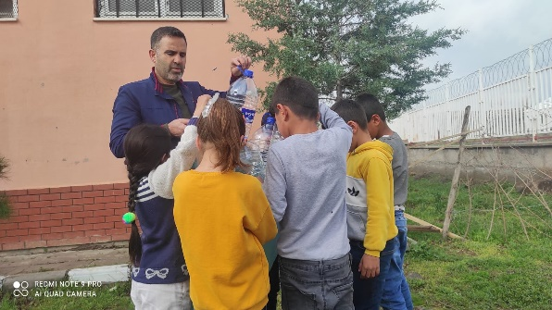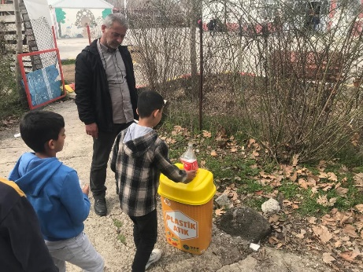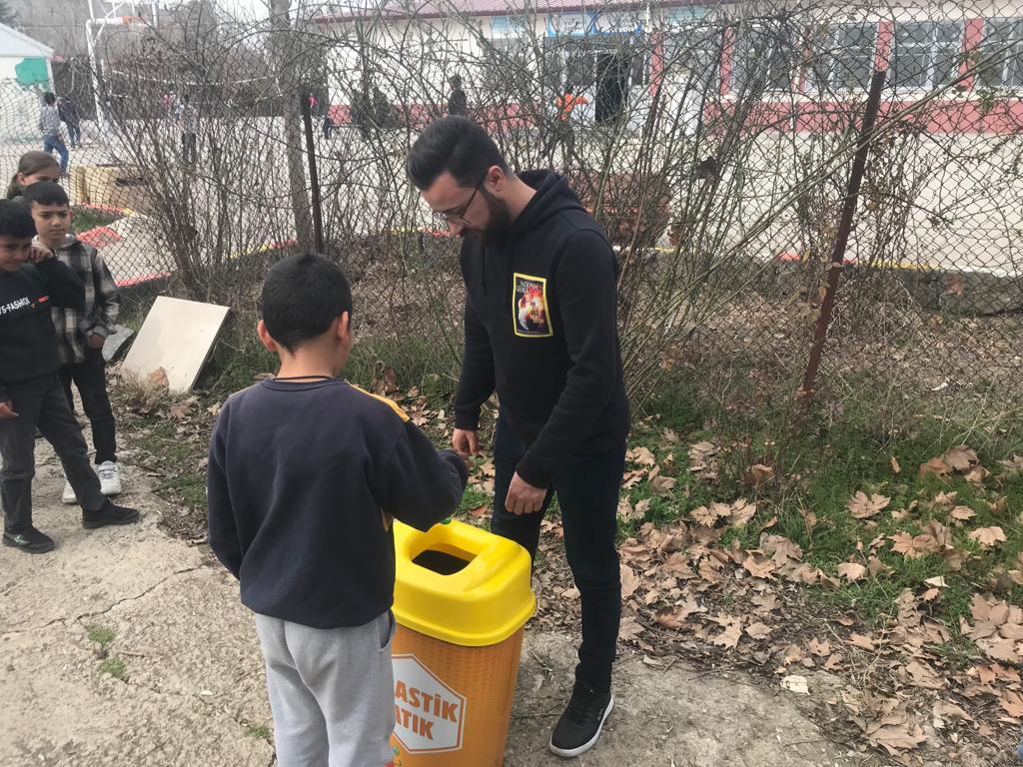

MARCH EVENT
As part this month and sent them for recycling.of the zero waste project, we collected waste batteries in our homes and schools.

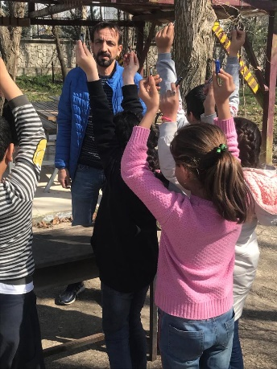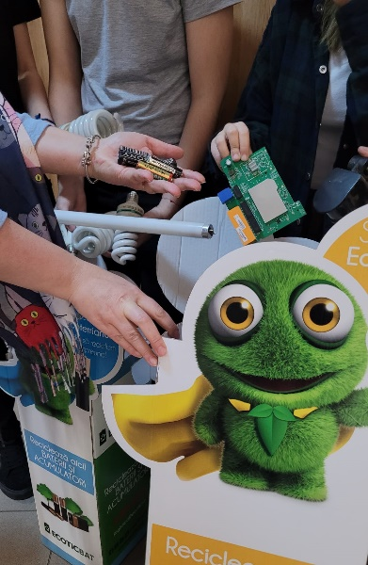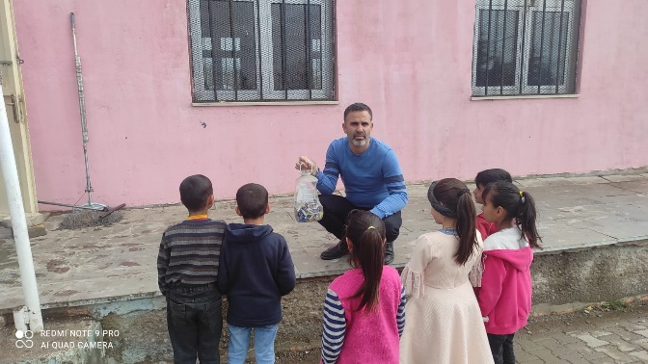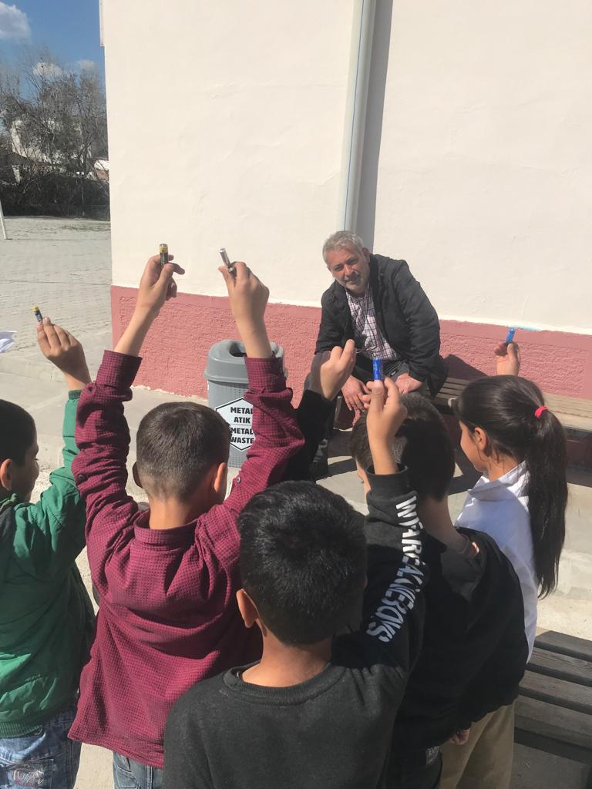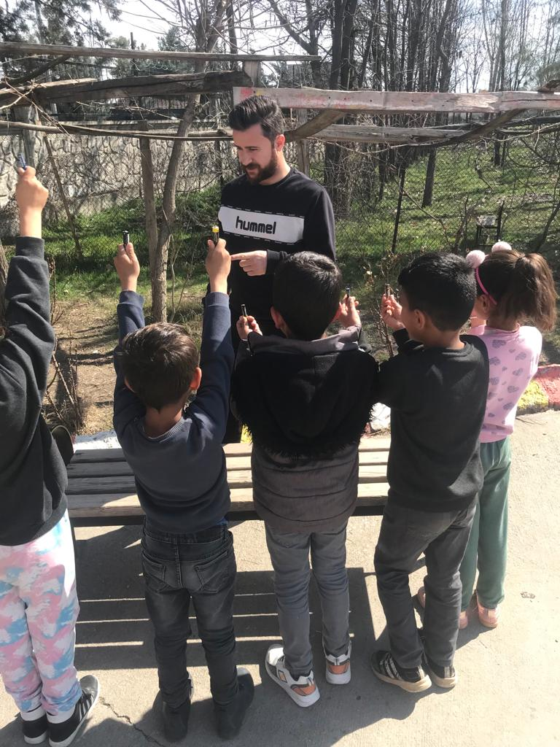

APRIL EVENT
Within the scope of the zero-waste project, we collected the clothes that children do not use, and delivering them to those in need by providing hygiene and sanitation.

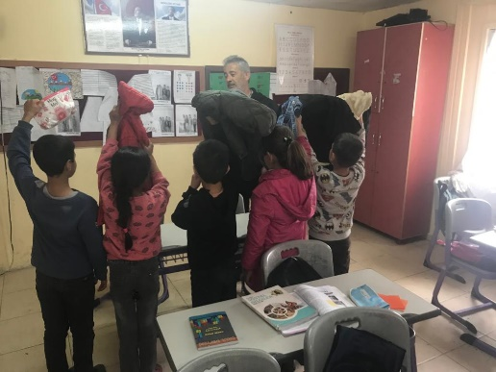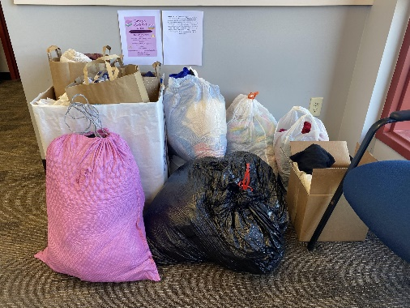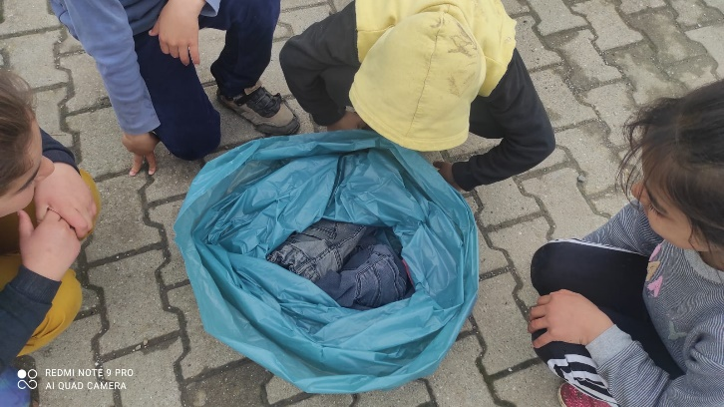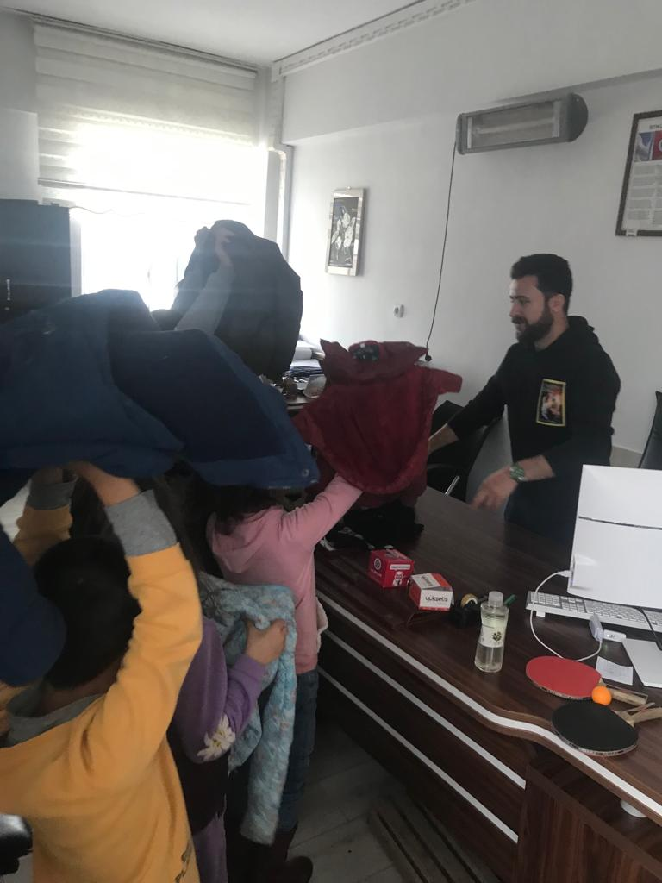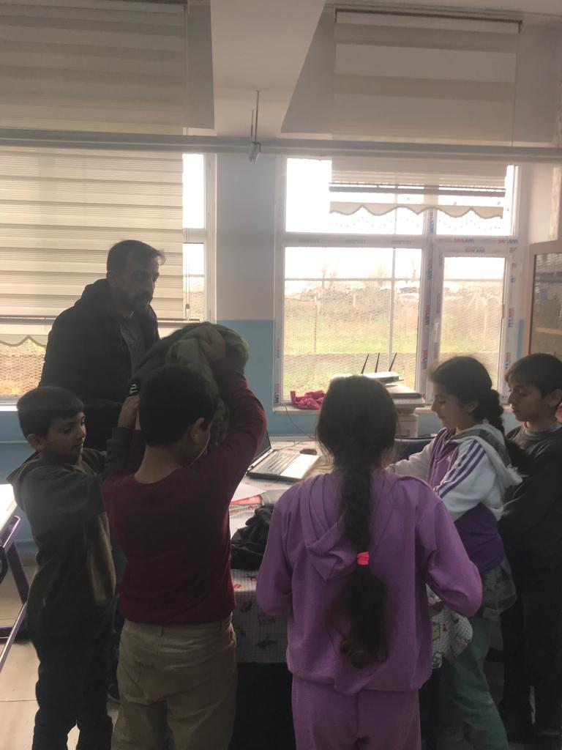

MAY EVENT

Together with our students, we designed a product by recycling waste. We exhibited these products at the virtual exhibition with the EMAZE web.2 tool.

https://app.emaze.com/@ALOTFWTZC/may-event

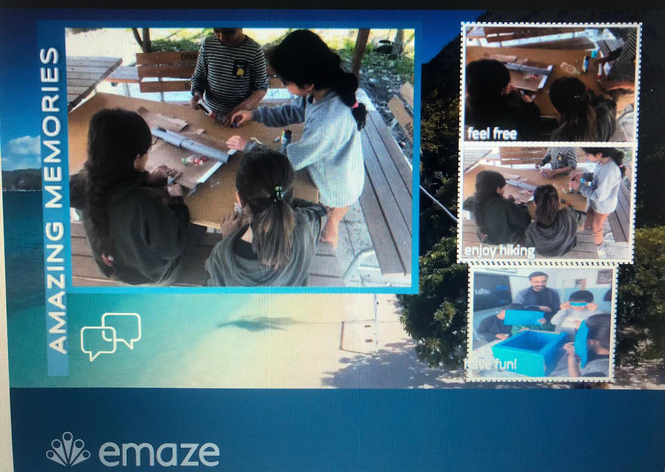

OUR LOGO
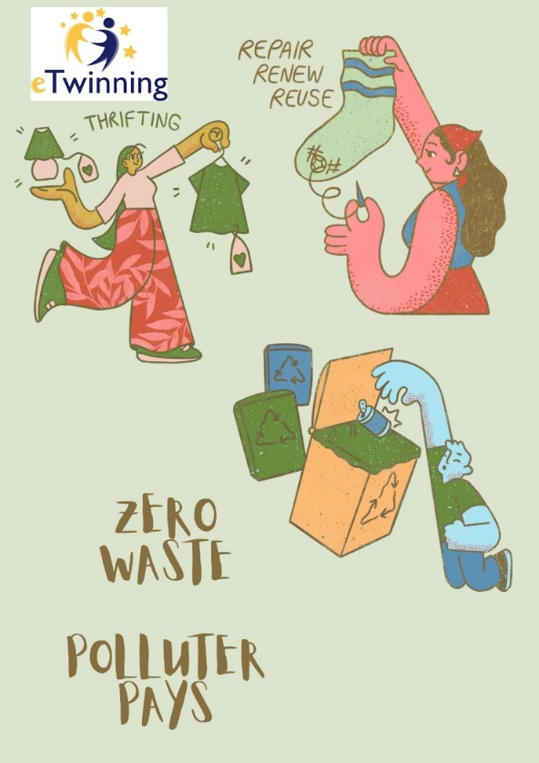

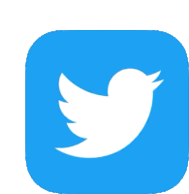
SOCIAL MEDIA ACCOUNTS

https://twitter.com/ZeroWas90344039

https://instagram.com/zerowastepolluterpays?igshid=NTc4MTIwNjQ2YQ==

https://www.youtube.com/channel/UCCoQOTDgEaKejBQCLE6XKDA

E- SAFETY - 8 FEBRUARY

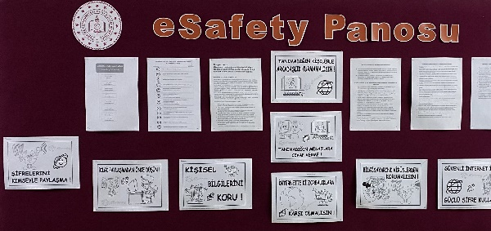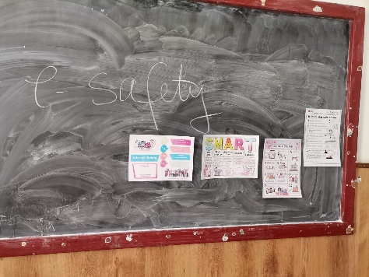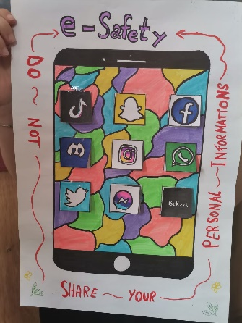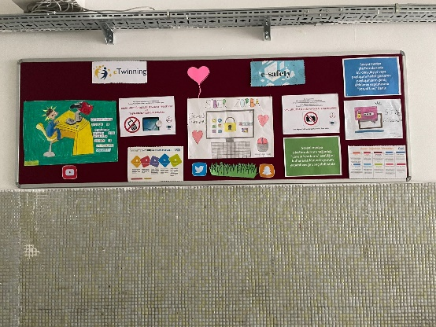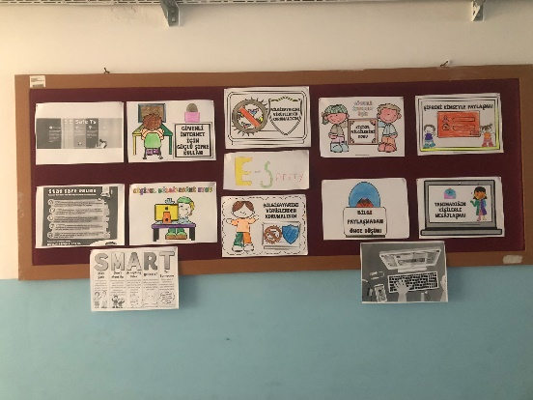
E-TWINNING DAY 9 MAY

WE CELEBRATED E-TWINNING DAY WITH OUR STUDENTS.

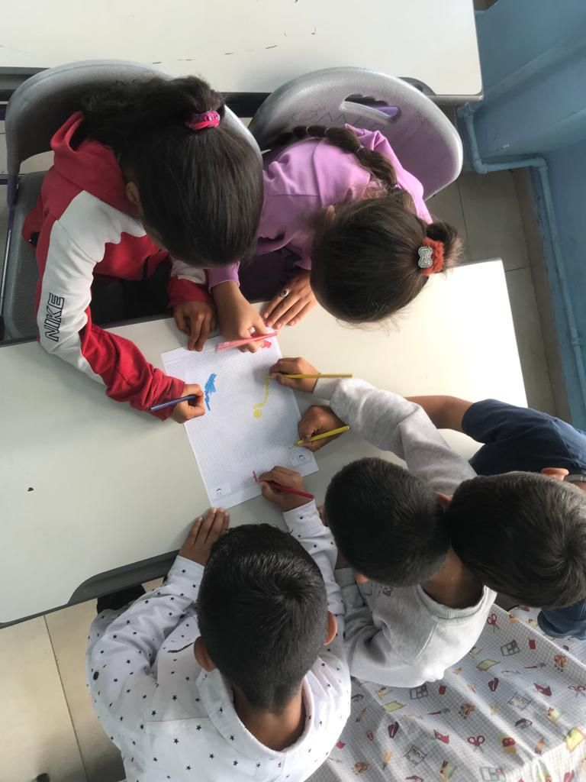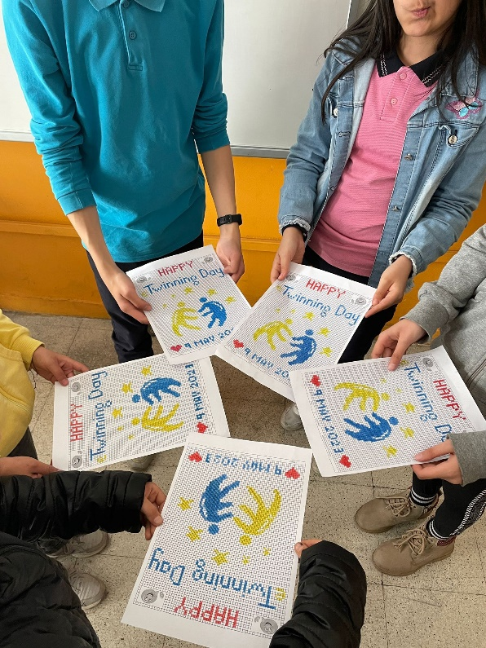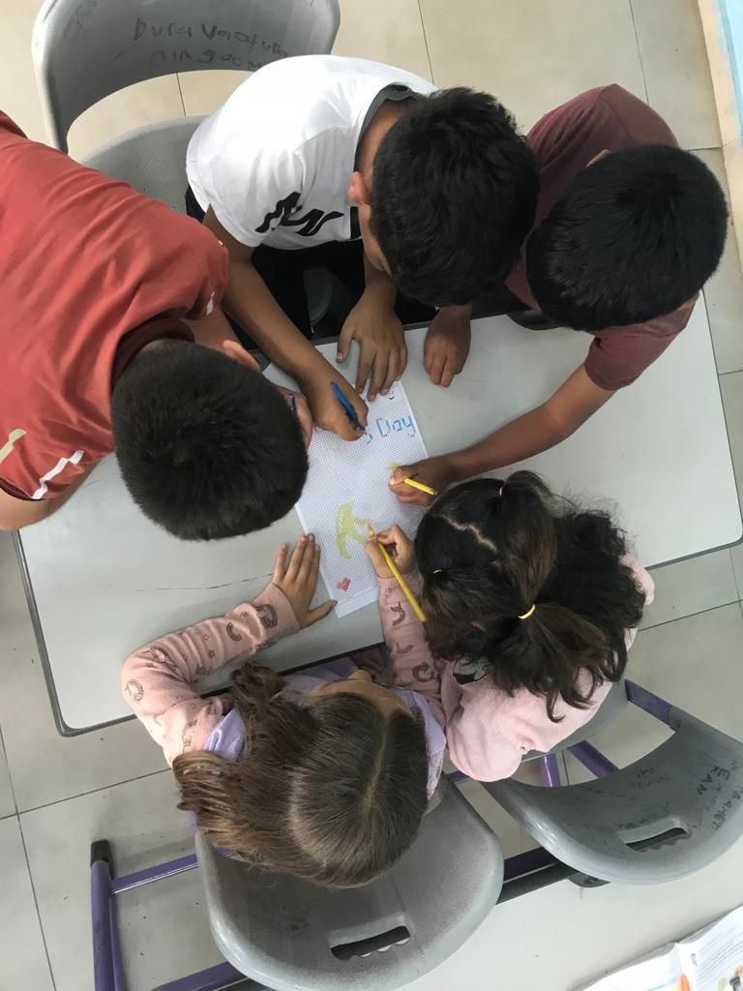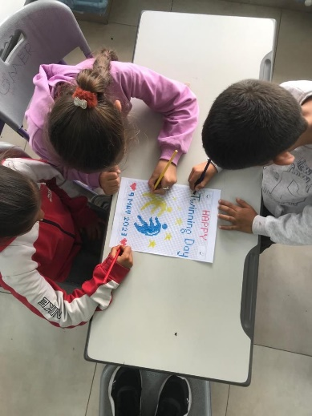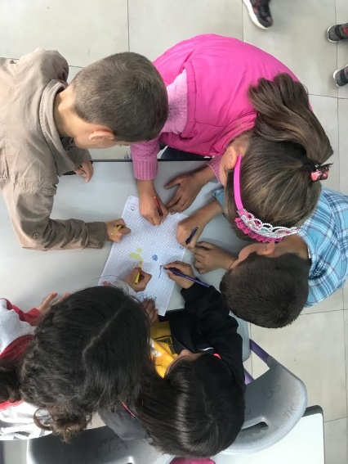

WORLD WATER DAY- 22 MARCH

WE CELEBRATED WORLD WATER DAY WİTH OUR STUDENTS. WE READ POEMS.

FINAL PRODUCT

EVERY SENTENCE OF OUR STORY "WHAT HAPPENED TO THE WASTE", WHICH WAS CREATED BY OUR STUDENTS, WAS WRITTEN BY A STUDENT.
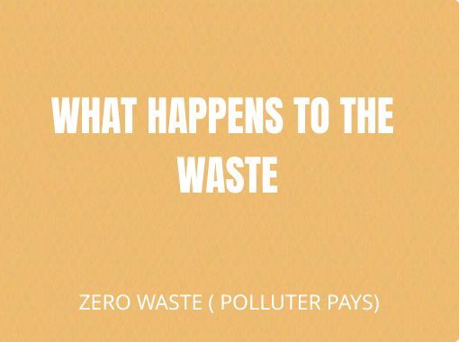

EVALUATION FORM (1st) PUPILS - RESULTS= IN THE FIRST SURVEY WE APPLIED TO OUR STUDENTS BEFORE STARTING OUR PROJECT, IT WAS OBSERVED THAT THE MOST OF THE STUDENTS HAVE NOT PARTICIPATED IN AN E-TWINNING PROJECT BEFORE. MOST STUDENTS ARE QUALIFIED ON ZERO WASTE BUT DO NOT KNOW HOW TO USE WEB.2 TOOLS. MOST STUDENTS DOMINATE TYPES OF WASTE.

EVALUATION FORM (1st) TEACHERS- RESULTS= IN THE FIRST SURVEY WE IMPLEMENTED OUR TEACHERS BEFORE STARTING OUR PROJECT, TEACHERS HAVE ENOUGH INFORMATION ABOUT THE CONTENT OF THE PROJECT. THEY BELIEVE THAT THE PROJECT WILL BE SUCCESSFUL AND THAT THEY CAN DEVELOP THEM ACADEMICLY. MOST TEACHERS ARE PARTIALLY KNOWLEDGEABLE OF WEB.2 TOOLS. THEY ARE VERY HAPPY TO PARTICIPATE IN THE PROJECT.

EVALUATION FORM (2nd) PUPILS - RESULTS= LOOKING AT THE SURVEY APPLICED TO THE STUDENTS AT THE END OF THE PROJECT, THE STUDENTS ARE EXTREMELY SATISFIED TO BE PARTICIPATED IN THE PROJECT. MOST OF THE STUDENTS ENJOYED THE ACTIVITY OF MAKING PRODUCTS FROM WASTE MATERIALS. EVEN AFTER THE PROJECT, THEY STATED THAT THEY WILL COLLECT WASTE PRODUCTS AND SEND IT FOR RECYCLING. THE PROJECT INCREASED AWARENESS OF THE STUDENTS, THE STUDENTS MADE NEW FRIENDS. THEY HAVE PRACTICED ENGLISH.

EVALUATION FORM (2nd) TEACHERS- RESULTS= LOOKING AT THE SURVEY TEACHERS ATTENDED AT THE END OF THE PROJECT, THE TEACHERS HIGHLY ENJOYED THE PROJECT. AFTER THE PROJECT, THE STUDENTS STATED THAT THEIR INFORMATION ON ZERO WASTE HAS CHANGED. THEY STATED THAT THEIR STUDENTS ARE VERY HAPPY WITH THE PROJECT PROCESS. THEY THINK THEY CAN GET THE QUALITY LABEL. THEY HAVE STATED THE NEW WEB.2 TOOLS THAT THEY DID NOT KNOW BEFORE

In our first meetıng, we introduce our students and give detailed information about our project.

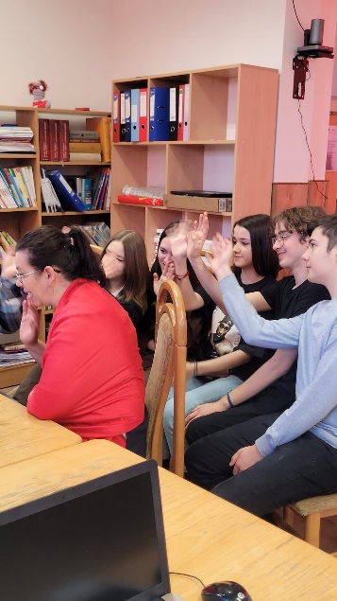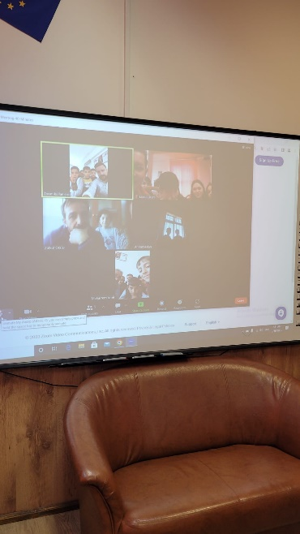

AT OUR SECOND MEETING, WE TALKED ABOUT WHAT WE DID IN THE PROJECT AND WHAT WE LEARNED FROM THE PROJECT. OUR STUDENTS STATED THEIR THOUGHTS ABOUT THE PROJECT.
